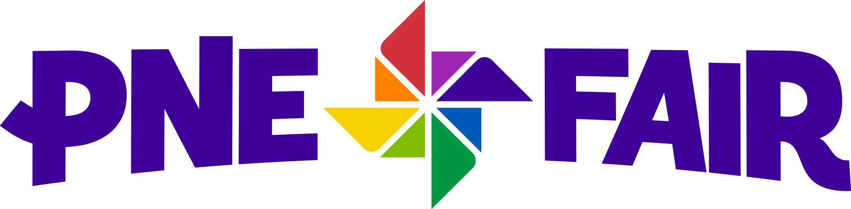

MEDIA ALERT

ZZ Top Concert at 2019 PNE Fair Cancelled

For Immediate Release
August 8, 2019

Vancouver, B.C. — The Pacific National Exhibition (PNE) has been notified that the August 18th ZZ Top concert has been cancelled. Band member Frank Beard has been diagnosed with a case of pneumonia and has been directed by doctors to recuperate before resuming performances.

“ZZ Top is loved by their fans here at the Fair as well as across British Columbia, and we’re all wishing Mr. Beard a speedy recovery,” says PNE Spokesperson Laura Ballance. “We anticipate announcing a replacement show for the August 18th date in the coming days.”

Ticket holders for the Reserved Seat section of the ZZ Top show will have the option of retaining their tickets when the new act is announced for that date or they can receive a full refund at the point of purchase. All ticket holders will be contacted by TicketLeader via the email account on their file. For more information visit: www.ticketleader.ca

For more information about PNE Fair visit: www.pne.ca

About the PNE:

Owned by the City of Vancouver, the Pacific National Exhibition (PNE) is a healthy and vibrant non-profit organization dedicated to delivering over 2 million visitors a year with memorable experiences through access to first-class cultural, music, sporting and family entertainment events, as well as access to public space for passive recreation. Founded in 1910, the PNE’s home is Hastings Park, a multi-facility venue in Vancouver where the organization manages four activity streams: the annual PNE Fair, Playland Amusement Park, Park Care and Facility Maintenance and an expansive portfolio of year-round events. All revenues generated are invested back into park space, community programs and non-revenue generating educational and entertainment experiences.
-30-

Media Contact:

Krystle Landert
PNE Fair
604.637.6661 (direct)
604.329.4747 (mobile)
KLandert@LBMG.ca

