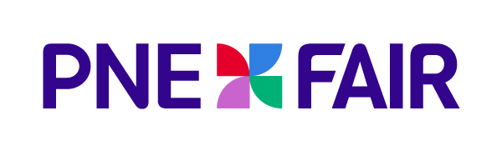
LONGTIME BROADCASTER MIKE MCCARDELL HONOURED AT 2024 FAIR

For Immediate Release
August 27, 2024

Vancouver, B.C. — No place in British Columbia has been the site of more stories by the iconic BC broadcaster Mike McCardell than right here at the PNE. For 47 years Mike has told the stories of our places and our people. From birds and fish in the sanctuary pond to the ride operators, food vendors, security staff, grounds keepers and Prize Home pitchmen, Mike has brought the stories of the people of the PNE to life.

As Mike has decided that the 2024 PNE Fair will be the final farewell to his long and storied career as a journalist, we are excited to honour him in a special thank you from the generations of PNE staff and fans who have enjoyed the stories of the human side of Hastings Park.

Members of the media and public are invited to join us as we, the PNE say our thanks to Mike McCardell for this wonderful journey we’ve had together.

Date: Thursday, August 29th
Time: 12:45pm
Location: PNE Agrodome

For more information about PNE Fair visit: www.pne.ca

About the PNE:

Owned by the City of Vancouver, the PNE is a healthy and vibrant non-profit organization dedicated to delivering over 3 million visitors a year with memorable experiences through access to first-class cultural, music, sporting and family entertainment events, as well as access to public space for passive recreation. Founded in 1910, the PNE’s home is Hastings Park, a multi-facility venue in Vancouver where the organization manages four activity streams: the annual PNE Fair, Playland Amusement Park, Park Care and Facility Maintenance and an expansive portfolio of year-round events. All revenues generated are invested back into park space, community programs and non-revenue generating educational and entertainment experiences.

-30-

Media Contact:

Laura Ballance
604.771.5176 (mobile)
Laura@LBMG.ca

