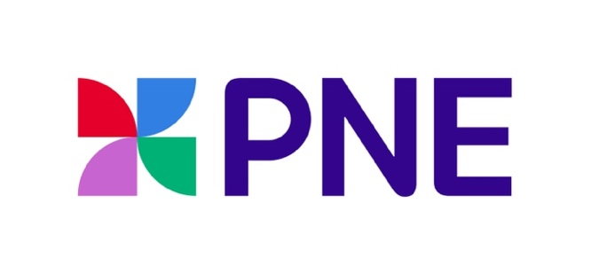
PNE ENTERS INTO PARTNERSHIP WITH INTERAC

For Immediate Release
Monday, August 12th

Vancouver, BC: The PNE is pleased to announce an important new corporate sponsorship for 2024 signing an agreement for Interac Corp. (Interac) to be the presenting partner of the Pacific National Exhibition (PNE) and preferred payment method for the Fair.

“We’re thrilled to welcome Interac as a new sponsoring partner of our organization,” says Vice President of Sales, Marketing and Business Development Karen Massicotte. “Given the number of annual transactions on our site across our many business streams, including the PNE Fair, this is a collaboration that assists our guests in many tangible ways.”

One of the benefits of the new relationship that is sure to be a hit with Fair guests includes a special Interac InLife Lounge in the Kids area of Playland. This lounge will be open during the Fair and will remain throughout the Playland season for the next three years. This fun, interactive area will allow young Fairgoers and families a special place to cool down thanks to the help of misters, a water refill station and unique experiences.

Guests can look forward to a fresh experience at The Market presented by Interac, the newly rebranded popular Marketplace building. This area will showcase the latest home products, featuring a variety of new artisan vendors. In addition, this partnership has made it possible to showcase a new section filled with a rotating group of small business and artisan exhibitors from FACE (Federation of African Canadian Economics). FACE is a national and bilingual, Black-led not-for-profit organization that focuses on providing resources and information to businesses across Canada founded and led by people of African descent.

“We’re proud to partner with the PNE for the next three years to bring payment choice to Fairgoers,” says Glenn Wolff, Group Head and Chief Client Officer, Interac Corp. “As the preferred payment method for the PNE, we’re helping make it easy for Fairgoers to securely and conveniently tap to pay for food, beverages, and game fare using their own funds.”
Dates and Pricing

The 2024 Fair will run from August 17th until September 2nd from 11am until 11pm. The Fair will be closed on Monday, August 19th and August 26th

Fair Gate Passes
Save $5 on adult gate passes and $2 on Youth, Child and Senior gate passes if you buy in advance!
Save an extra $5 if you go during the week (Tues-Thurs) and save 30% on Gate and Ride Passes with BCAA.

Adult (19-64) | $ 25.00
Youth (13-18) | $ 16.00
Child (4-12) | $ 9.00
Senior (65+) | $ 16.00
3 & under | $ FREE

Ride Passes

Save $5 on ride passes if you buy in advance!

Thrill Seeker | $ 55.00
Fun Pass | $ 44.00
Ride Coupon (each) | $ 2.00
Ride Coupon Book (30 tickets) | $ 54.00
Rapid Pass (add-on) | $ 32.00

Summer Night Concert tickets (with prices starting as low as $40.00 INCLUDING FAIR ADMISSION) are on sale at TicketLeader.ca. For more information about the PNE Fair visit: www.pne.ca

Connect with the PNE:
www.facebook.com/PNE.Playland/
https://instagram.com/PNE_Playland
http://www.twitter.com/PNE_Playland

About the PNE:
Owned by the City of Vancouver, the PNE is a healthy and vibrant non-profit organization dedicated to delivering over 3 million visitors a year with memorable experiences through access to first-class cultural, music, sporting and family entertainment events, as well as access to public space for passive recreation. Founded in 1910, the PNE’s home is Hastings Park, a multi-facility venue in Vancouver where the organization manages four activity streams: the annual PNE Fair, Playland Amusement Park, Park Care and Facility Maintenance and an expansive portfolio of year-round events. All revenues generated are invested back into park space, community programs and non-revenue generating educational and entertainment experiences.

-30-

Media Contact:

Laura Ballance
604.771.5176 (mobile)
Laura@LBMG.ca

